Safeguarding Vulnerable Adults Policy
Purpose
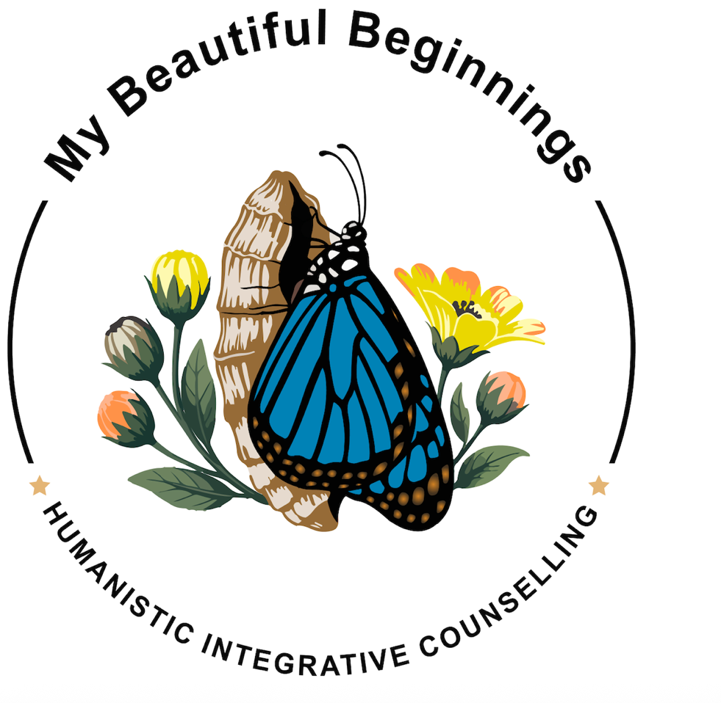
My Beautiful Beginnings Humanistic Integrative Counselling recognises the importance of safeguarding adults at risk and considers their welfare and protection to be a fundamental professional responsibility.
The practice is committed to promoting the welfare of adults at risk, preventing abuse and neglect wherever possible, responding appropriately to concerns, and maintaining clear safeguarding arrangements throughout the counselling services provided.
Safeguarding is everyone's responsibility. At My Beautiful Beginnings Humanistic Integrative Counselling, the practitioner holds overall responsibility for safeguarding in counselling.
Commitment to Safeguarding
I am committed to:
- Promoting the welfare and protection of adults at risk
- Protecting clients from abuse, neglect, exploitation and avoidable harm
- Taking concerns, disclosures and allegations seriously
- Responding to safeguarding concerns promptly and appropriately
- Recognising that abuse can occur in any family, community or setting
- Respecting the individual circumstances, identity, culture, disability, communication needs, beliefs and preferences of each client
- Maintaining appropriate professional boundaries
- Working within relevant safeguarding legislation, statutory guidance and professional ethical standards
- Seeking appropriate advice when I am unsure how to respond to a safeguarding concern
- Maintaining appropriate safeguarding records and documenting decisions and actions taken
Equality and Safeguarding
Safeguarding applies to all adults at risk regardless of age, disability, gender, gender identity, race, culture, language, religion or belief, sex, sexual orientation or any other characteristic.
I recognise that some individuals may face additional barriers to seeking help, reporting abuse or being heard. I will take these circumstances into account when considering safeguarding concerns and responding to disclosures.
Recognising Abuse and Neglect
Abuse and neglect can take many forms, including:
- Physical abuse
- Emotional or psychological abuse
- Sexual abuse
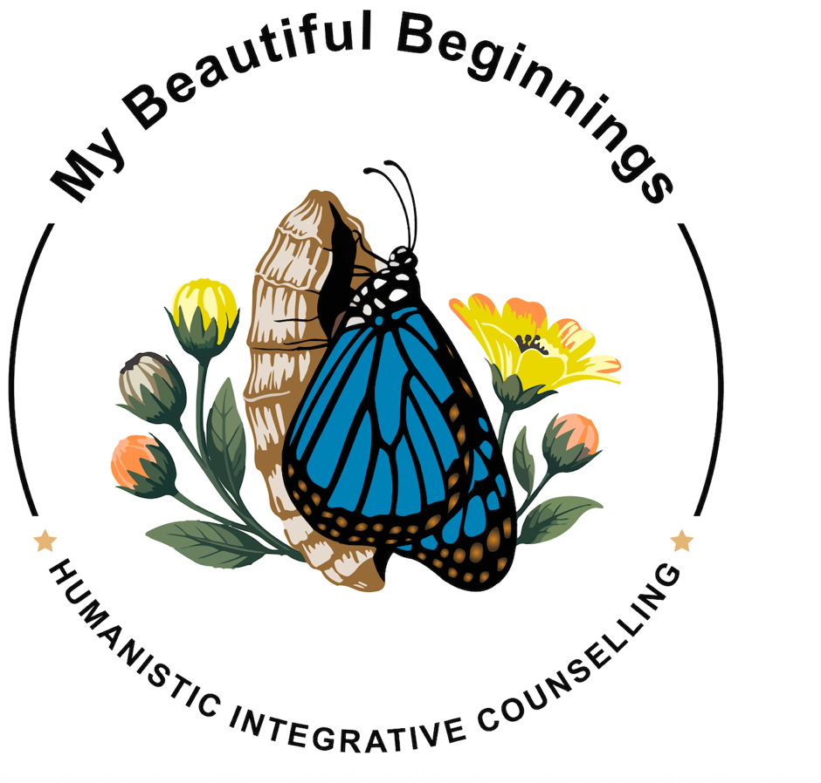
- Neglect
- Domestic abuse
- Financial or material abuse
- Discriminatory abuse
- Organisational or institutional abuse
- Exploitation
- Modern slavery and trafficking
- Online abuse and exploitation
- Self-neglect in appropriate adult safeguarding circumstances
A safeguarding concern does not need to involve certainty that abuse has occurred. Where something causes concern, I may seek advice from the appropriate safeguarding service to establish what action is required.
Responding to Disclosures and Concerns
Any disclosure or safeguarding concern will be taken seriously.
Where a client discloses abuse, neglect or another safeguarding concern, I will listen carefully, avoid making promises about confidentiality that I cannot keep, and take appropriate steps to record and respond to the information provided.
I will not undertake an investigation myself. Where appropriate, I will seek advice from the relevant safeguarding authority or make a referral in accordance with safeguarding procedures.
Information will only be shared where there is a lawful and appropriate basis for doing so, and information shared will be proportionate to the concern and the action required.
Where it is safe and appropriate to do so, I will explain to the client what information I need to share and why.
Adults at Risk
My Beautiful Beginnings Humanistic Integrative Counselling recognises that an adult may be at risk of abuse or neglect where they have care and support needs, are experiencing or are at risk of abuse or neglect, and are unable to protect themselves from that abuse or neglect because of those needs.
Safeguarding concerns relating to adults will be considered on an individual basis.
I recognise that an adult's vulnerability is not determined solely by disability, age, diagnosis or another personal characteristic. The circumstances, care and support needs, risks and ability of the individual to protect themselves will be considered.
Where appropriate, advice or a safeguarding referral may be made to the relevant Adult Safeguarding service.
Consent and Information Sharing
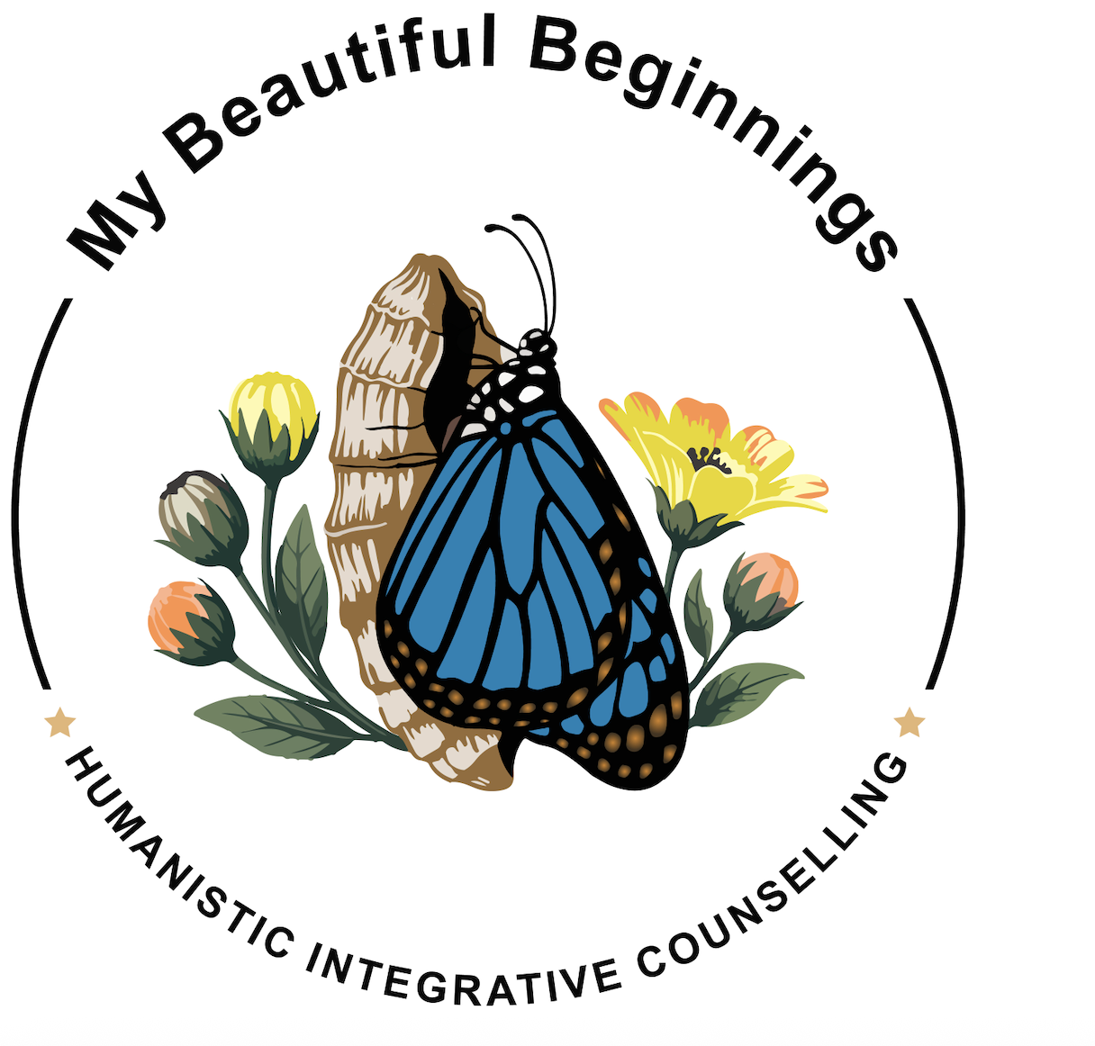
Adults with capacity will normally be involved in decisions about safeguarding information being shared.
However, there may be circumstances in which information needs to be shared without consent, including where:
- There is a serious risk of harm
- A child or another adult may be at risk
- There is a risk to other people
- A serious crime may have been committed or may be planned
- Information sharing is otherwise required or permitted by law
- Seeking consent could increase the risk of harm or prejudice an investigation
Safeguarding decisions will be made using professional judgement and, where appropriate, consultation with clinical supervision and relevant safeguarding professionals.
Safeguarding and Confidentiality
Confidentiality is an important part of the therapeutic relationship but is not absolute.
Where there is a safeguarding concern, information may need to be shared with an appropriate safeguarding service, healthcare professional, emergency service or other relevant agency.
Professional Safeguarding Responsibilities
I maintain responsibility for keeping my safeguarding knowledge and practice up to date.
This includes:
- Maintaining appropriate safeguarding training and continuing professional development
- Keeping informed about relevant legislation and statutory guidance
- Attending regular clinical supervision
- Seeking safeguarding advice when required
- Maintaining appropriate safeguarding records
- Reviewing safeguarding procedures regularly
- Considering learning from safeguarding concerns, incidents and changes in professional guidance
DBS Checks
I hold current Enhanced DBS checks relevant to my work with adults and maintain my DBS certificates through the DBS Update Service.
The DBS Update Service allows certificates to be kept up to date and enables eligible organisations to carry out status checks with the certificate holder's permission. The service searches for new conviction and barring information weekly and searches for relevant police information on Enhanced certificates every nine months.
The Update Service forms part of wider safeguarding arrangements and does not replace appropriate safeguarding procedures, professional judgement, supervision, training or other relevant checks. DBS guidance also makes clear that the Update Service should not be regarded as continuous monitoring.
Local Safeguarding Contacts
For safeguarding concerns relating to an adult at risk:
Luton Safeguarding Adults Team
Telephone: 01582 547730
Email: adultsafeguarding@luton.gov.uk
Luton Council advises that its Adult MASH receives safeguarding referrals concerning adults at risk of harm or abuse.
For urgent out-of-hours safeguarding advice, the Emergency Duty Team can be contacted on:
0300 300 8123
Emergency Situations
If there is an immediate risk of serious harm or a medical or other emergency requiring an urgent response, I will contact the appropriate emergency service.
999 should be called in an emergency.
Detailed Safeguarding Policies
My Beautiful Beginnings Humanistic Integrative Counselling maintains detailed safeguarding policies and procedures covering:
- Safeguarding Adults at Risk
- Responding to Disclosures
- Recording and Reporting Safeguarding Concerns
- Information Sharing
- Allegations Against the Practitioner
- Professional Boundaries
- Safer Working Practices
- Safeguarding Training and Competence
- Safeguarding Review and Learning
These documents form part of the My Beautiful Beginnings Humanistic Integrative Counselling Practice Suite and provide the detailed procedures underpinning this statement.
Review
This statement and the associated safeguarding policies will be reviewed regularly and following significant changes to legislation, statutory guidance, professional requirements, local safeguarding arrangements or the services provided by My Beautiful Beginnings Humanistic Integrative Counselling.

