Anti-Discriminatory, Equality & Diversity Statement
Purpose
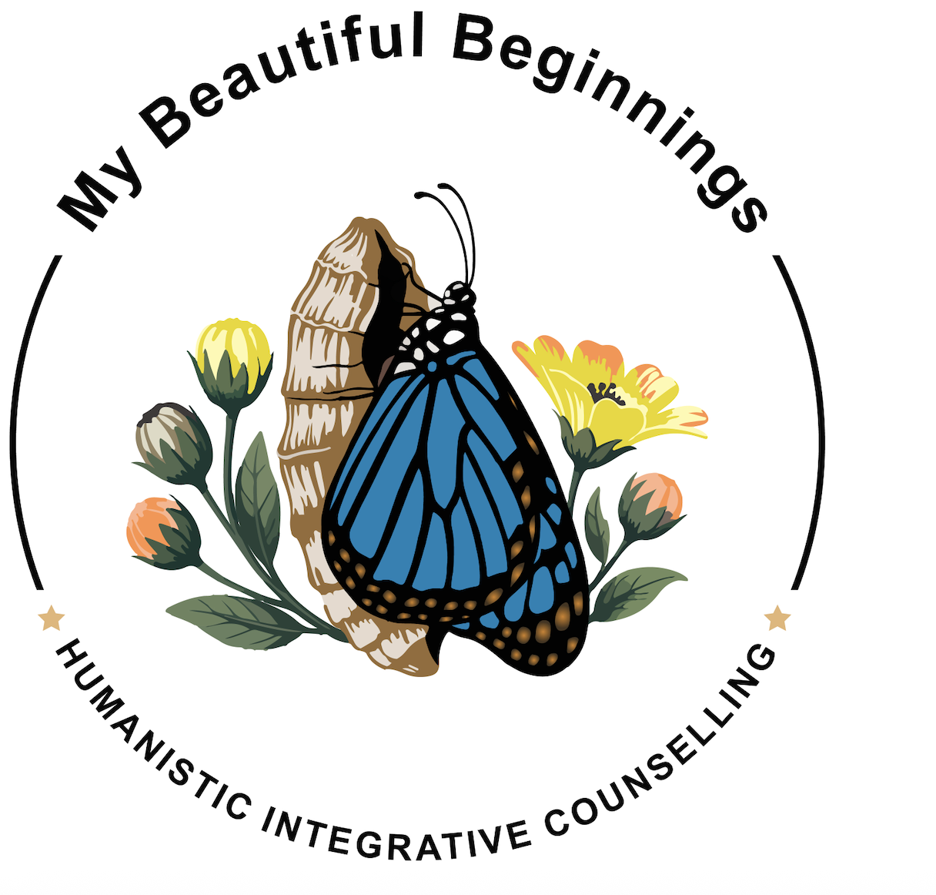
My Beautiful Beginnings Humanistic Counselling is committed to promoting equality, diversity and inclusion across all services provided by the practice. This statement explains the practice’s commitment to reducing discrimination, recognising individual differences, and ensuring clients are treated with dignity, fairness, and respect.
By considering this statement in my work, I aim to reduce discrimination and benefit those with protected characteristics.
Commitment to Equality and Inclusion
All clients of My Beautiful Beginnings Humanistic Counselling are treated with equal consideration. Wherever reasonably possible, adjustments will be made to facilitate access to the therapeutic process, and sessions will be adapted to reflect the individual needs, circumstances and preferences of each client.
Access to counselling and hypnotherapy services through My Beautiful Beginnings Humanistic Counselling is available regardless of:
- Age
- Disability
- Gender reassignment
- Marriage or civil partnership
- Pregnancy or maternity
- Race
- Religion or belief
- Sex
- Sexual orientation
These are the protected characteristics recognised under the Equality Act 2010.
Reasonable Adjustments and Accessibility
My Beautiful Beginnings Humanistic Counselling recognises that equality does not always mean treating everyone identically. Where possible, reasonable adjustments will be considered to reduce barriers to accessing services and participating in the therapeutic process.
Current limitations to accessibility include:
- Services are provided in English only, as I do not speak languages other than English.
- The practice office is situated on the first floor and is not accessible to individuals who are unable to use the stair lift or mobilise upstairs.
These limitations will be communicated honestly, and where appropriate, alternative arrangements or signposting to more suitable services may be considered.
Individual Understanding and Professional Responsibility
I recognise that each client is the expert in their own life, identity and lived experience. However, I will not rely on clients to educate me about the protected characteristics they identify with or experience.
Where I recognise that I require a deeper understanding of an aspect of a client’s identity, background or experience, I will take responsibility for developing my knowledge through appropriate reading, research, professional resources, relevant training and, where appropriate, discussion with individuals or organisations with relevant lived or professional experience.
This supports a therapeutic relationship in which clients are not placed in the position of having to teach their practitioner about their identity to receive appropriate support.
Sexual Diversity
My Beautiful Beginnings Humanistic Counselling respects and values sexual diversity. Non-heterosexual sexual orientations are not regarded as diseases, mental disorders, defects or developmental irregularities.
I will not engage in psychological therapy or other therapeutic activity intended to change or suppress a client’s sexual orientation.
I will support clients to explore their understanding of themselves, their relationships, their identity and their lived experience in a manner that respects their autonomy and dignity.
Recognition of Diverse Needs
I recognise that different ethnic, cultural, gender and minority groups may experience different barriers, pressures or needs when accessing therapeutic support.
I will make reasonable efforts to remain informed about relevant issues, resources and organisations, including agencies and services that focus on the interests and support needs of diverse communities.
Where appropriate, I will seek to develop my awareness and adapt my practice to ensure that clients are not disadvantaged by a lack of understanding or consideration.
Client Initiatives and Identity
My Beautiful Beginnings Humanistic Counselling is committed to encouraging and supporting the diverse initiatives, identities, interests and experiences of its clients.
Clients will be supported to explore their individuality and lived experience without being expected to conform to assumptions based on identity, background, diagnosis, presentation or protected characteristics.
Professional and Legal Framework
This statement is informed by the principles of equality, dignity, inclusion and respect, together with awareness of the requirements and protections established by the Equality Act 2010.
The protected characteristics covered by the Act are:
- Age
- Disability
- Gender reassignment
- Marriage and civil partnership
- Pregnancy and maternity
- Race
- Religion or belief
- Sex
- Sexual orientation
My Beautiful Beginnings Humanistic Counselling will continue to consider relevant legislation, professional ethical standards and good practice guidance when reviewing its approach to equality, diversity and inclusion.
Review
This statement will be reviewed regularly to ensure that it continues to reflect the needs of clients, developments in legislation and guidance, and the ongoing development of inclusive professional practice.

